Understanding Gradient Descent
Mathematical Foundations and Optimization Techniques
A comprehensive guide to Gradient Descent, covering its mathematical foundations, types, and practical challenges with visual aids.
Autor: Gemini 3 Flash Preview
February 2026

Introduction to Gradient Descent
Gradient Descent is a fundamental optimization algorithm used in machine learning to minimize a cost function. It iteratively adjusts parameters to find the minimum of a function.

How it Works
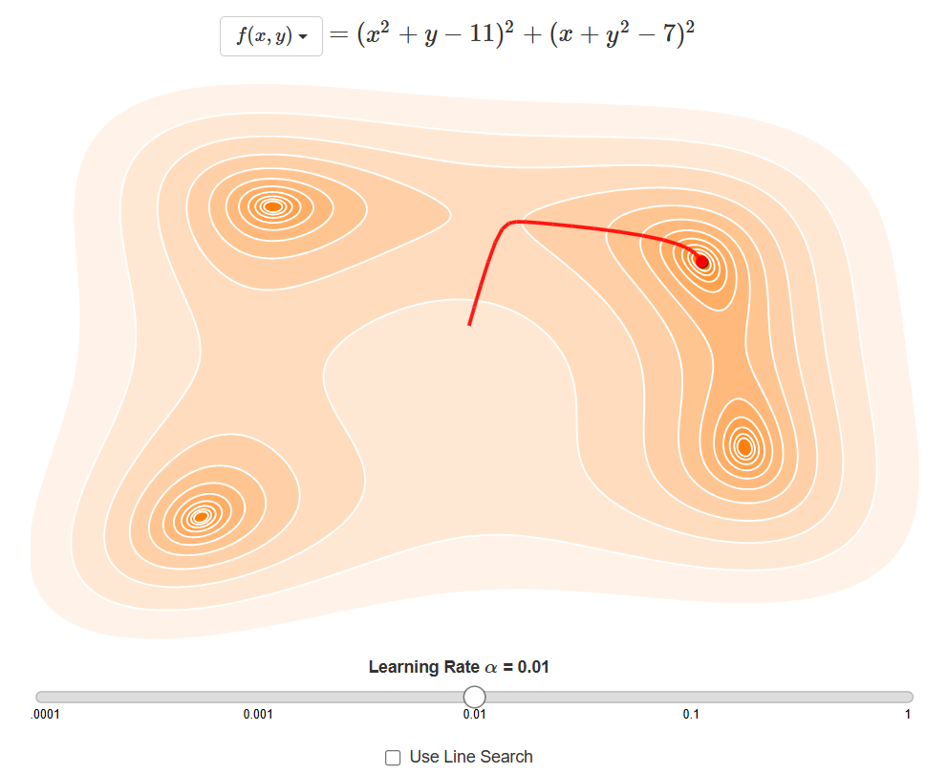
Figure 1: Visualizing the descent towards the minimum cost.
$$θ_{next}=θ-η·∇_{θ}J(θ)$$
Equation 1: The Gradient Descent update rule.
The algorithm starts with random initial values and takes small steps in the direction of the steepest descent, which is the negative of the gradient. The size of these steps is determined by the learning rate.

Mathematical Foundations
At its core, gradient descent relies on calculus. The gradient is a vector of partial derivatives that points in the direction of the steepest increase of the function.

The Role of Derivatives
$$\frac{ds}{dt}(t)=\lim_{dt→0}\frac{s(t+dt)-s(t)}{dt}$$
Equation 2: Definition of the derivative.
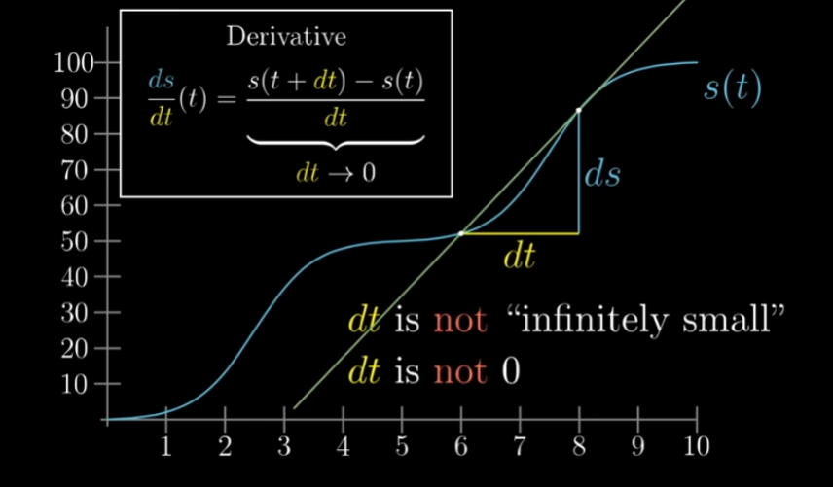
Figure 2: The definition of a derivative on a curve.
By calculating the derivative, we can determine the slope of the function at any given point. In optimization, we move against this slope to reach the bottom of the 'valley'.

Types of Gradient Descent
- Batch Gradient Descent: Uses the entire dataset to compute the gradient.
- Stochastic Gradient Descent (SGD): Uses a single random instance per step.
- Mini-batch Gradient Descent: Uses small random subsets of the data.
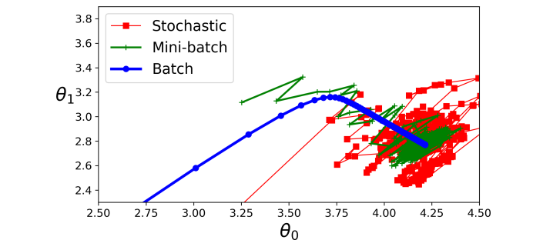
Figure 3: Comparing Batch, Stochastic, and Mini-batch paths.
$$f(x,y)=(x^{2}+y-11)^{2}+(x+y^{2}-7)^{2}$$
Equation 3: Cost function for two features.
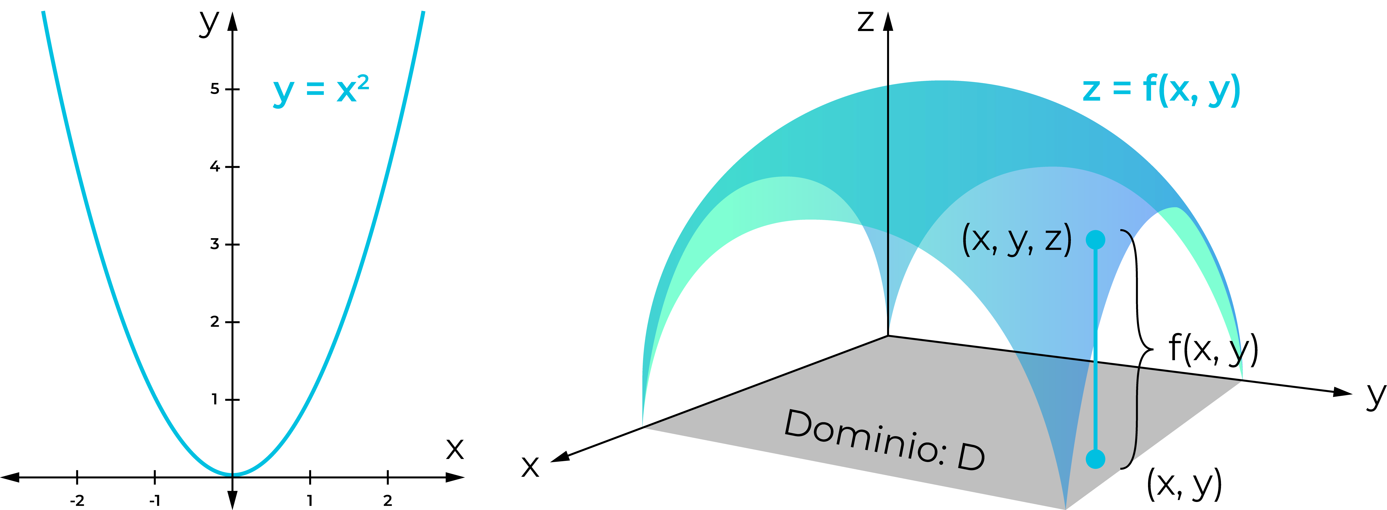
Figure 4: Gradient descent on a complex 2D cost surface.

Challenges and Pitfalls
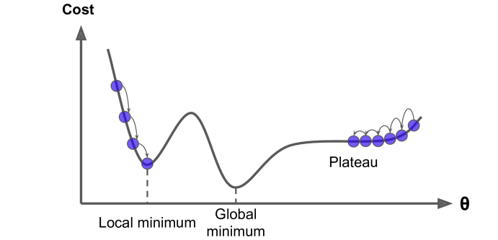
Figure 5: Common pitfalls: Local minima and plateaus.
Not all cost functions are convex. In non-convex functions, the algorithm might get stuck in a local minimum or crawl slowly across a plateau, failing to reach the global minimum.
Table 1: Comparison of Gradient Descent Variants
Variant | Data per Step | Convergence Speed | Stability
Batch | Entire Dataset | Slow | High
Stochastic | 1 Instance | Fast | Low (Noisy)
Mini-batch | Small Batch | Medium | Medium

